The never-ending, terrorizing history of Bride Kidnapping…
In a world pervaded by the concept of human rights and the freedoms awarded to all people, bride kidnapping is a ritual that has managed to sustain itself over time and is now a threat to modern societies.
Figure 1: Painting showing the kidnapping of the bride (Lenggries, engraving c. 1830, Upper Bavaria)

WHAT IS BRIDE KIDNAPPING?
Bride kidnapping, as the name suggests, is a practice where a man abducts a woman he wishes to marry. Simply put by VICE reporter Thomas Morton, “Guy wants to marry a girl, he gets a few of his friends together, they grab the girl off the street, then they drive her back to his place, and his mom and aunts try to convince her that marrying their son is the right move, even if he is a stranger”.
The ritual of bride abduction - as otherwise called - has been consistently practiced throughout prehistory and history, with examples like the Hmong people in Southeast Asia, the Roma population in Europe, and the Vikings from Northern Europe. The practice, although illegal in the majority of the world’s countries, can also be found today, mainly in parts of Africa or Central Asia.
Figure 2: A depiction of Vikings kidnapping a woman from a captured village (Liminais, 19th century)

CHARACTERISTICS OF BRIDE KIDNAPPING
As stated above, the majority of nations consider the act of bride abduction a sex crime. But why is that?
Bride kidnapping - as imagined - can at times include the assault or rape of a female to force her to agree to the marriage. And in today’s world, where gender equality has developed into an integral part of our society, such custom WILL NOT BE TOLERATED… right? WRONG!
Not only are there countries in the world that have enforced unwritten laws that encourage the act (including Ethiopia and Afghanistan), there is a common trend in which customary practice is valued more than actual laws. An example of that may be found in Kyrgyzstan, where officers are often disregarding or are entirely ignorant about the illegality of bride kidnapping.
Bride kidnapping is also often regarded as a form of child marriage, as the victims may be underage. In Ethiopia, for example, the majority of marriages start with the kidnapping of the bride, whose age may even reach that of eleven. The abductor then rapes his victim until she becomes pregnant, and he can then claim her as his wife. A similar procedure can be found in the novel “The Bride Price” of African author Buchi Emecheta, where Aku-nna is abducted by Okoboshi. While Aku-nna manages to escape, she was supposed to be held hostage until she agreed to the marriage. In this incident, and in others in real life, bride kidnapping is often connected to a woman’s bride price, as well as the (in)ability of someone to pay for it.
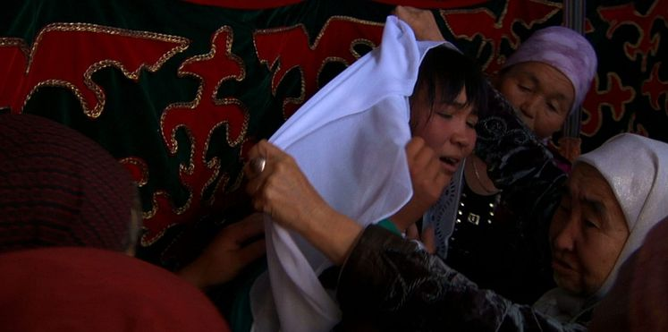

Figure 3: A Kyrgyz woman resisting to wear the veil, a cloth that symbolizes her agreement to the marriage

THE RESULTS OF A BRIDE KIDNAPPING MARRIAGE
Bride kidnapping is a life-altering experience. Being abducted and then obliged to marry and live with the person that took you away from your family is a situation not many can withstand. It is thus understandable to see that 60% of these marriages end in divorce, but shocking to hear that the majority of the remaining 40% end due to bride suicide or the kidnapper fatally assaulting the wife.
Even in cases where women were able to free themselves from her abductor, the social pressure placed on them is too significant to handle. They are often found victims of social criticism due to them abandoning the ancient ritual, causing mental trauma and leading to them either entering the world of prostitution or migrating to another nation without keeping in touch with any relative.

CONCLUSION
Bride kidnapping is an ancient ritual respected by and followed in several parts of the world. It is sometimes organized for tradition purposes only, and is often considered as part of the cultural relativism movement that has successfully protected a number of traditions that seem to violate human rights.
The truth, however, is that the practice of it is by all means illegal. Despite the people’s willingness to entertain the ritual, the governments of almost all states in which the ritual takes place have banned the tradition and have characterized it as a violation of basic human rights. It should therefore be clear that such practices shall be judicially punished, while the social standards established in these communities should be met with criticism by all individuals or parties involved.

REFERENCES
“'Bride Kidnapping' Haunts Rural Kyrgyzstan, Causing Young Women to Flee Their Homeland.” Yahoo! News, Yahoo!, https://news.yahoo.com/bride-kidnapping-haunts-rural-kyrgyzstan-123516085.html?fr=sycsrp_catchall.
Roxy. “15 Awful Realities about Bride Kidnapping.” Theclever, Theclever, 19 Aug. 2017, https://www.theclever.com/15-awful-realities-about-bride-kidnapping/.
vice. “Bride Kidnapping in Kyrgyzstan.” YouTube, YouTube, 19 June 2012, https://www.youtube.com/watch?v=DKAusMNTNnk.
“Weird Traditions All over the World.” Shuffle, 5 Apr. 2016, https://shuffle923.wordpress.com/2016/04/05/weird-traditions-all-over-the-world/#:~:text=Bride%20Kidnapping%20%28Romani%20Gypsies%29%20Kidnapping%20is%20illegal%2C%20and,the%20rights%20to%20get%20married%20to%20the%20girl.

vice. “Bride Kidnapping in Kyrgyzstan.” YouTube, YouTube, 19 June 2012, https://www.youtube.com/watch?v=DKAusMNTNnk.

